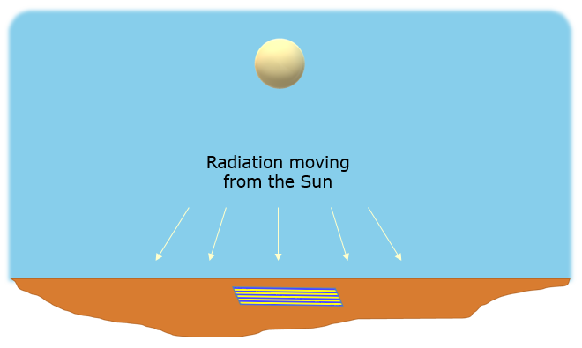
Heating the towel

Radiation from the Sun is lighting the towel.
Radiation from the Sun is heating the towel.

a. When does the Sun heat the towel most quickly?
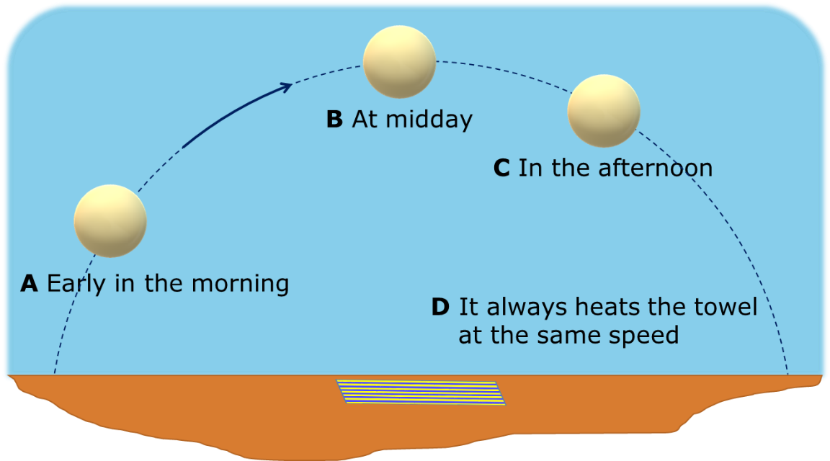

b. What is the best reason for your last answer?
Put a tick (✓) in the box next to the best answer.
A | The Sun’s temperature is unchanging
B | The Sun is closer
C | The distance to the Sun is always the same
D | The heat radiation is more spread out
E | The heat radiation is less spread out

Physics > Big idea PES: Earth in space > Topic PES2: Earth and Sun > Key concept PES2.1: Days and seasons
Diagnostic question
Heating the towel

Overview
Learning focus: | The temperature is higher in the summer because the tilt of the spinning Earth increases the length of a day and increases the heating effect of the Sun’s radiation.
Observable learning outcome: | Explain why the angle of the Sun changes the effect of its heating.
Question type: | Two-tier multiple choice
Key words: | Radiation, heating, heat radiation

What does the research say?
In the summer one reason temperatures are higher is because the part of the Earth experiencing summer is tilted towards the Sun. This means the Sun is higher in the sky and the radiation from it is spread out over a smaller area of land giving a bigger heating effect. Ojala (1992) suggested representing the uneven distribution of the Sun’s radiation over the Earth’s surface with a diagram that shows how equal amounts of radiation spread. Küçüközer (2008) used a computer simulation to show what proportion of all radiation reaching the Earth fell above or below the equator during the summer and the winter.
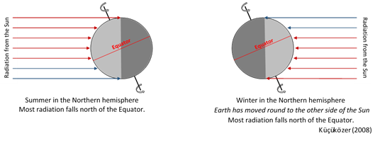
In text book diagrams, rays representing radiation from the Sun reaching the poles appear significantly longer than those reaching the equator. Such diagrams can reinforce the misunderstanding that it is warmer in the summer because we are closer to the Sun. When students encounter these diagrams for the first time they often do not have an accurate understanding of scale and do not realise that the differences in distances here are too small to make a noticeable difference to temperature (Ojala, 1992; Ojala, 1997). Ojala also found that the common practice of showing all four seasons on one diagram caused confusion and suggested using a separate diagram for each season.
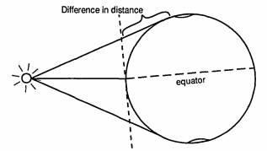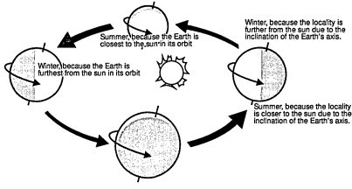
Ojala (1997)
The most common reason students (wrongly) give for why it is warmer in the summer is the Earth being closer to the Sun at that time (Allen, 2014; Driver et al., 1994; Baxter, 1989). Bakas and Mikropoulos (2003) found that Greek students aged 11-13 (n=102) were more likely to explain that higher temperatures in summer are caused by the Sun being higher in the sky, or because the days are longer, but without explaining the cause of these phenomena.
Constructivist teaching strategies that challenge student misunderstandings were shown to significantly improve knowledge about the causes of seasons (Trumper, 2006) and elicit longer retention of the scientific concepts (Tsai and Chang, 2005).
Ways to use this question
Students should complete the questions individually. This could be a pencil and paper exercise, or you could use an electronic ‘voting system’ or mini white boards and the PowerPoint presentation. The follow on question will give you insights into how they are thinking and highlight specific misconceptions that some may hold.
If there is a range of answers, you may choose to respond through structured class discussion. Ask one student to explain why they gave the answer they did; ask another student to explain why they agree with them; ask another to explain why they disagree, and so on. This sort of discussion gives students the opportunity to explore their thinking and for you to really understand their learning needs.
Differentiation
You may choose to read the questions to the class, so that everyone can focus on the science. In some situations it may be more appropriate for a teaching assistant to read for one or two students.
Equipment
For the class:
- A torch with a strong, wide beam (or a ray box with no slits fitted)
Expected answers
a. B: at midday.
b. E: The heat radiation is less spread out.

How to respond - what next?
For part a most students are likely to select answers B or C because they will have experienced the day getting warmer as it progresses. In the summer it is often hottest in the afternoon because the ground has had more time to warm up.
Part b may challenge some students to consider if the Sun is heating the towel at a constant rate, because answers A and C are correct statements about the Sun: the Sun’s temperature is unchanging and it is approximately at a constant distance from the Earth, but they do not explain changes experienced through a day.
Answer B is potentially a wrong answer because students’ everyday experience tells them that the closer they are to a constant source of heat, the greater the heating effect. As the Earth spins on its axis, the distance from a point on its surface to the Sun varies by 0.004% at most (and is closest in January). The change in heating effect because of this is negligible compared to other factors.
Answer D suggests students are confusing the amount of ground that is being heated with the amount of heat radiation falling on a particular area.
If students have misunderstandings about why the angle of the Sun affects heating, it can help to use a torch with a strong beam in a dimmed room to challenge misunderstandings and to demonstrate how the angle of light affects the brightness of the illuminated area:
- The change of distance from the light source to the Earth, as the Earth spins, changes by up to 4mm in every metre. Students will not be able to notice a change in brightness of the area illuminated by a torch moved from 1m to 1.004m from a target.
- Keeping the torch 1m from a target, but changing the angle it is shone at will show a clear change in brightness. When the angle is made more oblique, the illuminated area dims as the same amount of light radiation from the torch spreads over a larger area.
- Shining the torch onto a globe can show how the angle that radiation hits a point on the Earth changes as the Earth spins on its axis.
The following BEST ‘response activity’ could also be used in follow-up to this diagnostic question:
- Response activity: Getting warm
Acknowledgments
Developed by Peter Fairhurst (UYSEG).
Images: Peter Fairhurst (UYSEG).
References
Allen, M. (2014). Misconceptions in Primary Science, 2nd edn Berkshire, UK: Open University Press.
Bakas, C. and Mikropoulos, T. (2003). Design of virtual environments for the comprehension of planetary phenomena based on students' ideas. International Journal of Science Education, 25:8, 949-967.
Baxter, J. (1989). Children's understanding of familiar astronomical events. International Journal of Science Education, 11 (Special Issue), 502-13.
Driver, R., et al. (1994). Making Sense of Secondary Science: Research into Children's Ideas, London, UK: Routledge.
Kucukozer, H. (2008). The effects of 3D computer modelling on conceptual change about seasons and phases of the Moon. Physics Education, 43(6), 632-636.
Ojala, J. (1992). The third planet. International Journal of Science Education, 14:2, 191-200.
Ojala, J. (1997). Lost in space? The concepts of planetary phenomena held by trainee primary school teachers. International Research in Geographical & Environmental Education, 6:3, 183-203.
Trumper, R. (2006). Teaching future teachers basic astronomy concepts-seasonal changes-at a time of reform in science education. Journal of Research in Science Teaching, 43(9), 879-906.
Tsai, C. and Chang, C. (2005). Lasting effects of instruction guided by the conflict map: Experimental study of learning about the causes of the seasons. Journal of Research in Science Teaching, 42(10), 1089-1111.

